Milestone Two
Jordan Bankston
CS 465
Professor Chipman
February 12, 2025

System Architecture View

Sequence Diagram
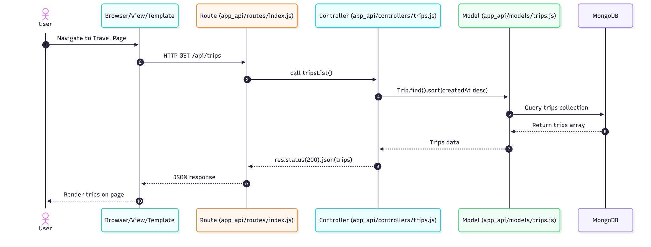
This sequence diagram illustrates the flow of data retrieval for the GET /api/trips endpoint in the Travlr Getaways application. When a user navigates to the travel page, the browser sends an HTTP GET request to /api/trips. The request is handled by the Express router in app_api/routes/index.js, which forwards the request to the tripsList() function in app_api/controllers/trips.js.
The controller executes a Mongoose query using Trip.find().sort({ createdAt: -1 }).lean() to retrieve all trip records from the MongoDB database, sorted by creation date in descending order. MongoDB returns the matching trip documents to the model layer, which passes the results back to the controller.
The controller constructs a JSON response containing a success message, a count of records returned, and the array of trip objects. This response is sent back to the client with HTTP status code 200. The browser then renders the retrieved trip data on the page for the user.
This flow demonstrates the separation of concerns between the route layer, controller logic, data model, and database within the full stack architecture.
Class Diagram
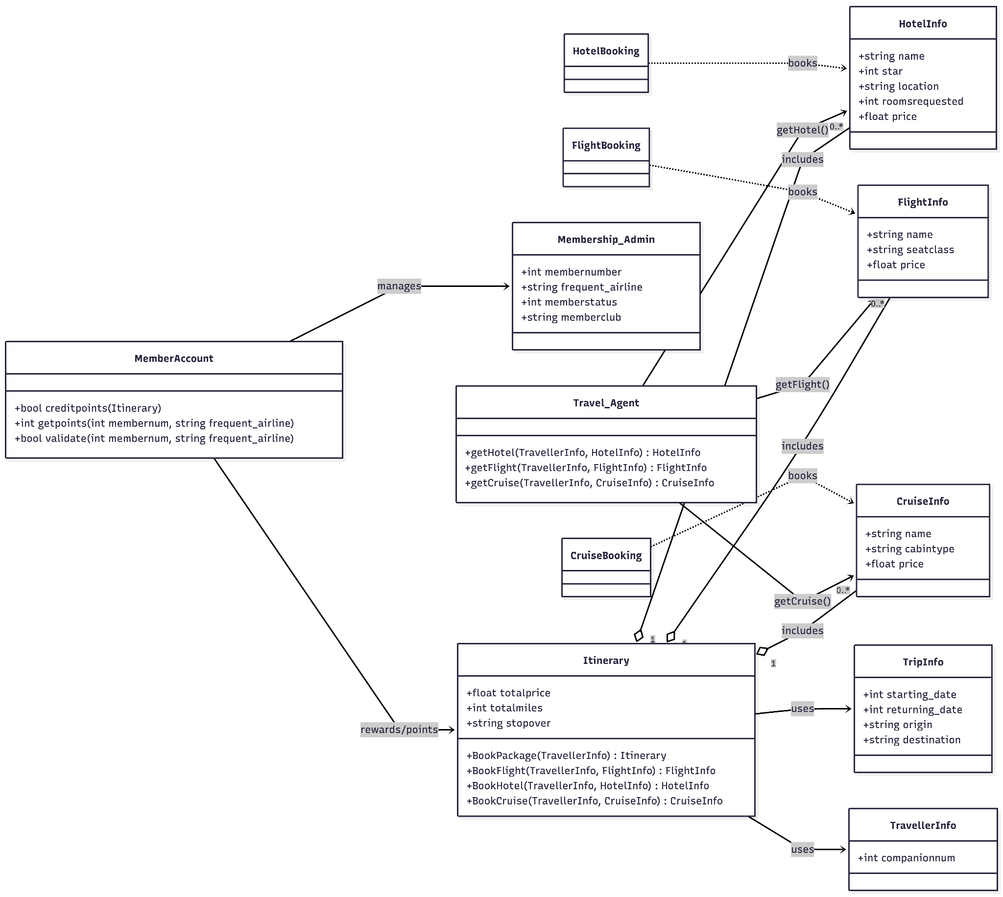
The class diagram represents the object-oriented structure of the Travlr Getaways application. The Itinerary class serves as the central aggregation component that organizes selected travel elements, including FlightInfo, HotelInfo, and CruiseInfo. Each of these classes contains attributes describing pricing and travel-specific details.
The Travel_Agent class acts as a coordinating component responsible for retrieving available travel options through methods such as getHotel(), getFlight(), and getCruise(). Booking responsibilities are encapsulated within the FlightBooking, HotelBooking, and CruiseBooking classes to separate reservation logic from core data models.
TripInfo and TravellerInfo store contextual travel data, including travel dates, origin, destination, and companion information. Membership functionality is handled by MemberAccount and Membership_Admin, which manage validation and reward point tracking associated with itineraries.
This design promotes modularity, separation of concerns, and maintainability within the application architecture.

HTTP Method | URL | Controller Function | Purpose | Notes
GET | /api/trips | tripsList | Retrieves all trip records from the database | Returns JSON containing message, count, and trips array.
GET | /api/trips/:tripid | tripById | Retrieves a single trip by its ID | Validates ObjectId format before querying database.
POST | /api/trips | tripsCreate | Creates a new trip record | Returns HTTP 201 with created trip object.
PUT | /api/trips/:tripid | tripsUpdate | Updates an existing trip | Validates ObjectId and returns updated document.
DELETE | /api/trips/:tripid | tripsDelete | Deletes a trip record | Returns HTTP 204 on successful deletion.

